Project: Flight Plan Chicago
Difficulty: Level 1

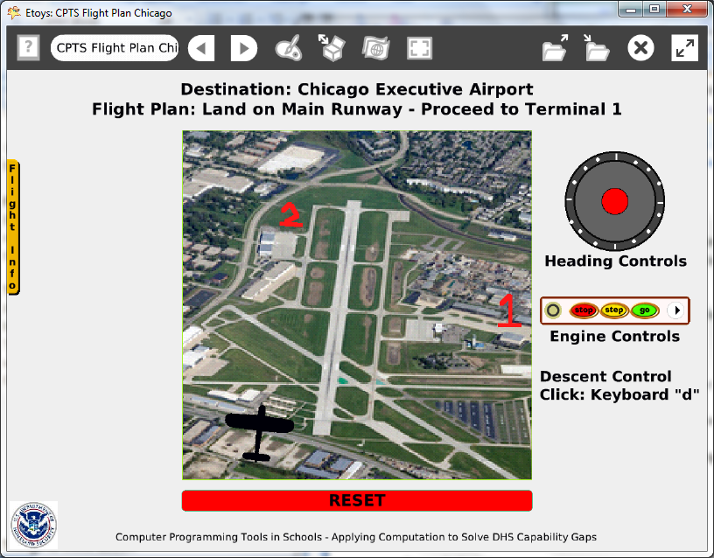

Time: Three 45 minute labs

Challenge:
Make a pilot training simulation that uses a joystick to land an aircraft at a specific location on a Google Earth image of a real airport.

Programming:
Uses basic script tiles, a constructed tile, a conditional statement, a sibling copy

Things you’ll need to know:
Quick Guides
- Paint Tools/ All
- Halo Handles/All
- Make a new Flap
- Tests
- Forward by
- Heading
- Scale Factor
- Text
- Joystick
- All Scripts Button

Things to think about:
- Why use a conditional statement?
- What is the difference between ticking, paused, and normal?
- What was the purpose of the sibling copy aircraft?

Extensions:
- Use sibling copies to make a fleet of aircraft: will the joystick be adequate to control the fleet?

NETS for Students:
http://www.iste.org/standards/nets-for-students/nets-student-standards-2007.aspx
1. Creativity and Innovation: a, b, c
2. Communication and Collaboration: b
3. Research and Information Fluency: a, b, c
4. Critical Thinking, Problem Solving, and Decision Making: a, b, c
5. Digital Citizenship: a, b
6. Technology Operations and Concepts: a, b, c, d

CSTA:
CSTA Level II: Objectives and Outline
http://csta.acm.org/Curriculum/sub/CurrFiles/L2-Objectives-and-Outlines.pdf
Level II objectives for middle school students are furthered through studying a programming language well enough that the student is proficient with it. Whether the language is Etoys, StarLogo TNG, or Scratch, it is the ability to use the language to express ideas that is valuable. A student skillful enough to use any programming language to express ideas, solve problems, model behaviors, simulate data, or to educate or entertain is an entitled person in today’s society. Topics of particular note are:
Topic 2: Problem Solving
Topic 6: Connections between Mathematics and Computer Science
Topic 11: Programming Languages
Topic 13: Multimedia

Common Core Standards Mathematics:
http://www.corestandards.org/the-standards/mathematics
6. EE.2, 6.RP.3, 6.NS.5

Teacher Notes:
Materials: provide a folder of airports and aircraft images. Students should include attribution info for photographs and web sites.

Comments: The scripts are not difficult but the decisions take time.

Objects - Scripts – Decisions:
Airfield image: Select, resize, use Grab patch to reduce number of pixels, lock image in the playfield
Playfield: Resized
Aircraft Image: Select, resize and repaint
Script with forward tile, scale factor decrease tile, and a constructed tile combining heading and joystick commands
Script conditional to test if the plane has arrived at the correct location
World: reset script
Button to fire this script, color and size changed
Joystick: location, size and color changed
Flap: name, relocate and change color
Text: title, game directions, quote

Example Scripts:

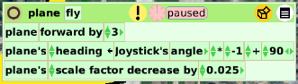

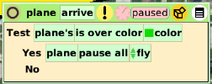

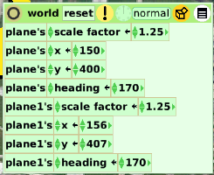

Student Notes:
None provided.

